Updated 6 April 2018

Mapping partnerships
and connections

Working in partnership with other agencies recognises the diverse expertise within the wider community and family violence sector, and strengthens the ability of the hospitals to respond to family violence in the most appropriate way. It is helpful to draw a partnership map showing the key family violence services within your local community and how well you are connected.

Step One – Identify
There are a number of ways hospitals can identify family violence service providers / agencies:
- Work with the Family Violence Regional Integration Coordinator (RIC) to undertake a mapping exercise.
- Visit the The Lookout website to identify the available services in your area. Go to the Services Directory at: http://www.thelookout.org.au/sector-info/service-directory
- Invite family violence sector representatives to undertake this work as a small working party (comprising representatives from hospital and sector)
- Draft documents for feedback from external, local and specialist family violence and sexual assault services

Step Two – Analyse
Analyse the current partnerships / referral pathways your hospital has in place with the local services you identified in Step One.
Consider:
- How strong is your hospital’s partnership / relationship with each agency? (refer to the key on the following map)
- What is the referral pathway to each service?
- Which service providers and relationships are the most important or potentially important and should therefore be strengthened.

Step 3 – Map out
Draw a map to show current partnerships and their strength.

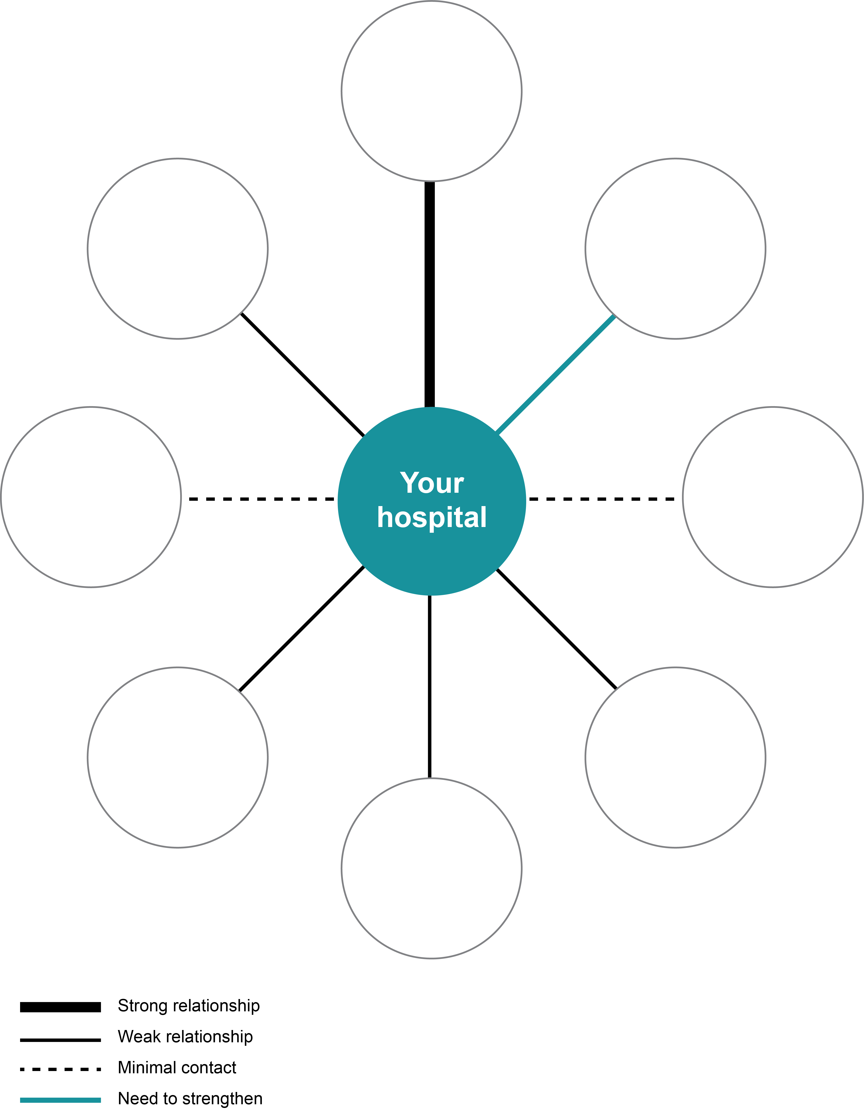

Step 4 – Document
Document your partnerships in the provided template and include actions for the Reference Group.

Agency | Reason for connection | Strength of connection | Action | Who will action | When | Costs
Centre for Sexual Assault (CASA) | Referral (primary referrals and secondary consultations)  Joint training  Information sharing | Weak | Invite CASA representative onto the Reference Group | SHRFV Project manager | Within 1 month | nil

