Updated 28 May 2018

Evaluation Framework for SHRFV funded hospitals

Evaluation is a structured process of assessing the success of a project in meeting its goals/objectives and to reflect on the lessons learned. There are two components to evaluation recommended to evaluate your SHRFV project.

1. Process Evaluation
Process evaluation refers to measuring the quality of the implementation of the project and is the first step in an evaluation framework. If the project has not been successfully implemented, then any attempt to measure the outcomes from the project will be affected. For example, if the quality of training to front-line clinicians was poor, then the impact of the training on improved patient outcomes cannot be measured.

2. Outcome Evaluation
Outcome evaluation refers to measuring the extent to which the implementation of the project has led to the expected benefits to the target population. In the context of the SHRFV project an outcome evaluation will likely pertain to a number of measures such as whether there has been an increase in the number of patients accessing specialist support services as a result of front-line clinicians identifying family violence, or whether patients are going home with a safety plan.
In the early stages of implementing the SHRFV approach, the focus will be on process evaluation. However, setting up an evaluation framework at the outset will ensure data is gathered to conduct both process and outcome evaluation.

The RE-AIM evaluation framework
The RE-AIM evaluation framework provides a structure for the design of an evaluation. It was first developed to evaluate public health interventions so is well suited to short-term clinical engagements with consumers. RE-AIM stands for:
- Reach to your intended target population
- Effectiveness
- Adoption by target staff, or settings
- Implementation consistency, costs and adaptations made during delivery
- Maintenance of intervention effects in individuals and settings over time
The evaluation framework below applies the RE-AIM framework to the SHRFV approach. It provides evaluation questions applied directly to each of the five elements of the SHRFV approach to evaluate the extent to which the model was successfully implemented (process evaluation) and to measure the outcomes of the project (outcome evaluation).
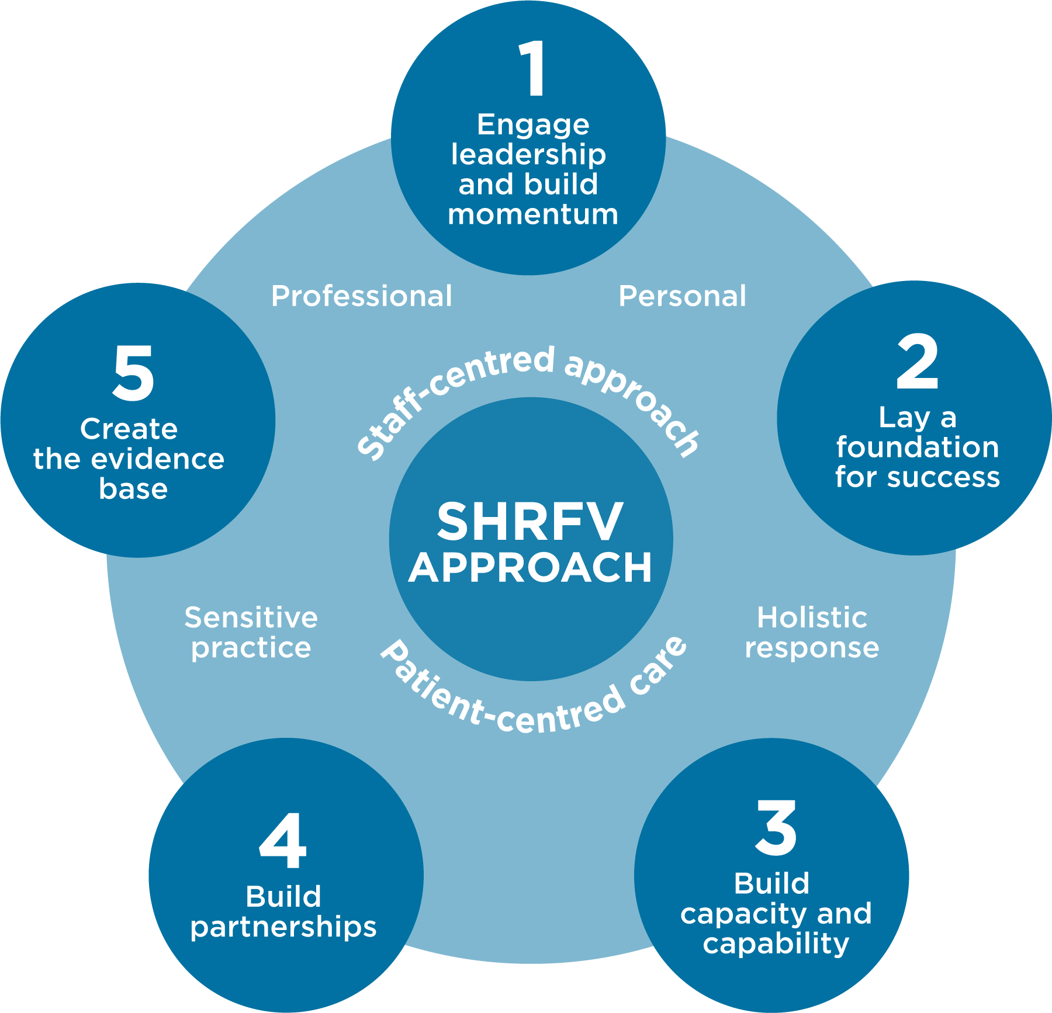
The evaluation framework will enable Project Managers to report on the following key project measures:
- Do clinicians know how to ask and respond to patients with signs of family violence?
- Post training are clinicians putting sensitive inquiry into practice?
- What response are clinicians receiving – disclosure or non-disclosure?
- What type of referrals are being offered – internal or external?
- Are referrals being accepted?
- What is the patient perspective of being asked about family violence in the hospital setting?
- What is the patient perspective of the support / referral provided?

Process Evaluation Framework:
Strengthening Hospital Responses to Family Violence Project

Element One: Engage leadership and build momentum
 | Evaluation Questions | Indicators | Data Sources
REACH | Have all hospital leaders received a face to face SHRFV project briefing? | 100% participation | Training attendance records
 | Has a reference group been established with leadership representation? | Involvement in Reference Group | Reference Group Terms of Reference
EFFECTIVENESS | What evidence is there of leadership contributing to the project? | Executive sponsor appointed | Reference Group minutes
 | Is there an identifiable SHRFV project manager at the hospital? | Appointment made
ADOPTION | Are hospital leaders providing resources to support the project e.g. recruitment of family violence clinical champions? | Implementation Plan approved by Reference Group | Reference Group minutes
 | Has a hospital position statement on family violence been agreed and promoted? | Position statement documented | Clinical champion meeting minutes
 | Has staff orientation been adapted to include information about the SHRFV project? | Orientation agenda | Website, newsletters, training records  Orientation agenda
IMPLEMENTATION | Have necessary governance documents been developed and approved by the Reference Group?  - Risk management plan  - Implementation plan  - Communication plan  - Budget plan including provisions for sustainability | All documents developed and approved | Reference Group minutes
 | What percentage of hospital leadership and line management have participated in family violence workforce support training? | 100% participation | Training attendance sheets
MAINTENANCE | Are there processes in place for review of the Reference Group? | Review incorporated into project plan as per ToR | Project plan
 | Are there processes for Reference Group members to report back to their areas on the progress of the project? | Agenda items for members to report on progress | Reference Group meeting minutes

Element Two: Lay a foundation for success
 | Evaluation Questions | Indicators | Data Sources
REACH | What percentage of hospital staff have been reached with Module One training? | 85% participation | Training attendance sheets
 | Have workplace support (professional and personal) options been documented and promoted across the hospital? | Communication action plan | Intranet, handouts, newsletters, training records
 | How has the hospital contributed to public education/awareness about family violence? | Invitations to speak | Media coverage, event agendas
EFFECTIVENESS | Are staff aware of family violence policies, procedures and workplace support relevant to staff? | 100% awareness post training | Training evaluation  Newsletters
 | What proportion of staff consider family violence a health issue relevant to the hospital? | 100% post training | Training evaluation
ADOPTION | Are staff applying the family violence policies, procedures and workplace support relevant to staff | Number of staff applying for leave | Leave applications  EAP records  Intranet views
IMPLEMENTATION | Has a gap analysis been conducted of current policies and practice? | Gap analysis documented | Reference Group meeting minutes
 | Have all policies, procedures and guidelines for patients and staff required to support the SHRFV project (identifying and responding to family violence, documenting disclosures, support to staff) been approved through the appropriate channels? | 100% of policies and procedures approved | Documents
 | Has a decision been made about how and what data is collected? | Process for collecting data endorsed | Reference Group meeting minutes
MAINTENANCE | Are there processes in place to review the effectiveness of the policies and procedures? | Regular review as per hospital protocol | Reference Group minutes

Element Three: Build capacity and capability
 | Evaluation Questions | Indicators | Data Sources
REACH | How many staff from identified rollout areas participated in Module Two clinical practice training? | Number and % of staff in identified departments | Clinical education records
 | How many staff from identified roll out areas have participated in supplementary clinical practice training? (E.g. SHRFV supplementary modules, DV Alert etc) | Number and % of all staff per year | Training attendance sheets
EFFECTIVENESS | What proportion of staff stated they had increased knowledge and confidence to identify and respond to family violence and sexual assault following the training? | 90% of training participants | Training evaluation surveys
ADOPTION | Are staff applying the approved policies and procedures regarding family violence identification, response and documentation following training? | 80% of training participants | 3 month follow up survey to training participants
 | Are processes in place to identify barriers to applying policies and procedures? | Barriers identified and addressed
IMPLEMENTATION | Are processes in place to review training delivery (enablers and barriers)? | Documented enablers and barriers in project reports | Trainers feedback sheets
MAINTENANCE | What processes have been implemented to reinforce learnings and continue to build the capacity of clinicians? | Implementation plan to include reflective practice, case review sessions | Clinical Champions ToR and meeting minutes
 |  | Clinical Champions Program

Element Four: Build partnerships and connections
 | Evaluation Questions | Indicators | Data Sources
REACH | Has family violence and sexual assault referral mapping occurred? | Referral mapping documented | Mapping tool
EFFECTIVENESS | What processes have been used to strengthen partnerships (face to face meetings, membership on Reference Group, MOU’s) | Formalised partnerships with key referral agencies | Project implementation reports
ADOPTION | Are clinical staff aware of internal and external referral sources following training? | 90% of staff aware of internal and external referral pathways | 3 month post training surveys
IMPLEMENTATION | Are processes in place to identify enablers and barriers to effective referral? | Identified enablers and barriers documented and addressed | 3 month post training surveys  Clinical Champion reports
MAINTENANCE | What processes are in place to maintain strong relationships with partners/referral services? | 6 monthly meeting with relevant internal and external stakeholders to discuss referral pathways | Number of referrals made to specialists FV services

Element Five: Create the evidence base
 | Evaluation Questions | Indicators | Data Sources
REACH | How many incidents of family violence have been documented? | Number of incidents documented hospital wide (or in targeted rollout areas) | Medical record (EMR / DMR / paper based)
EFFECTIVENESS | Are processes in place to review the documentation forms? | 50% of files identified FV audited | Medical record audit (EMR / DMR / paper based)  Reference Group minutes
ADOPTION | Are documentation forms being completed well – factual, succinct, with relevant alerts | 80% of documents to training standard | Medical record audit (EMR / DMR / paper based)
IMPLEMENTATION | Are processes in place to analyse data gathered from the family violence documentation process? | Quarterly family violence data reporting hospital wide (or in | Medical record audit (EMR / DMR / paper based)
MAINTENANCE | Is analysed data being used to engage clinicians? | Feedback provided to clinicians about outcomes and referrals | Case reviews where FV has been identified

Outcome Evaluation Framework:
Strengthening Hospital Responses to Family Violence Project
Note: Where patients are involved, ethical processes and standards must be applied

Objective: Improved safety and wellbeing of patients experiencing family violence and sexual assault following a clinicians’ identification and response.
 | Evaluation Questions | Indicators | Data Sources
REACH | Are patients aware that they can safely speak to a clinician at this hospital about family violence concerns? | Number and % of patients that report being asked | Survey of patients in waiting rooms/wards
 | How many patients have made a disclosure of family violence and past sexual assault? | Number of disclosures | Medical record audit (EMR / DMR / paper based)
EFFECTIVENESS | Clinicians are consistently applying sensitive practice with women patients? | Number and % of | Post training survey of clinicians
 | What referrals are offered to patients? | Recorded referrals | Medical record audit (EMR / DMR / paper based)
 | Are patients accepting a referral to family violence or sexual assault support following a disclosure? | % of referrals accepted/declined
ADOPTION | Has clinical practice changed as a consequence of the SHRFV training? | Training report | Post training survey of clinicians  Feedback from Clinical Champions
 | Are clinicians applying self-care in relation to working with family violence and sexual assault patients? | Self Care report | EAP report  Clinician survey
IMPLEMENTATION | Are processes in place to seek feedback from patients about their experience of being asked about family violence enquiry? | Patient feedback report | Post appointment phone call survey
 | Are processes in place to seek feedback from patients about the support / referral they were offered?
MAINTENANCE | What processes are in place to ensure sensitive practice becomes routine clinical practice? | Number and % of patients who report high levels of comfort and safety | Post appointment phone call survey
 |  | Model of Clinical Champions implemented | Clinical Champions anecdotal reporting

